**B.TECH IN COMPUTER ENGINEERING**

**Year:** 2023  **Semester –** 5th



**Prepared By: Jadav Sahil**

**Paghdal Mitul**

**Chandvaniya Yash**

SCHOOL OF ENGINEERING RK UNIVERSITY

RAJKOT (GUJARAT-INDIA) 360001

Software Requirements Specification

For

Book World System

Version 1.0 approved

<Rk University>

<23/10/2023>

Table of Contents

Table of Contents ii

Revision History ii

1. Introduction 1

1.1 Purpose 1

1.2 Document Conventions 1

1.3 Intended Audience and Reading Suggestions 1

1.4 Project Scope 1

1.5 References 1

2. Overall Description 2

2.1 Product Perspective 2

2.2 Product Features 2

2.3 User Classes and Characteristics 2

2.4 Operating Environment 2

2.5 Design and Implementation Constraints 2

2.6 User Documentation 2

2.7 Assumptions and Dependencies 3

3. System Features 3

3.1 System Feature 1 3

3.2 System Feature 2 (and so on) 4

4. External Interface Requirements 4

4.1 User Interfaces 4

4.2 Hardware Interfaces 4

4.3 Software Interfaces 4

4.4 Communications Interfaces 4

5. Other Nonfunctional Requirements 5

5.1 Performance Requirements 5

5.2 Safety Requirements 5

5.3 Security Requirements 5

5.4 Software Quality Attributes 5

6. Other Requirements 5

Appendix A: Glossary 5

Appendix B: Analysis Models 6

Appendix C: Issues List 6

Revision History

|  |  |  |  |
| --- | --- | --- | --- |
| **Name** | **Date** | **Reason For Changes** | **Version** |
|  |  |  |  |
|  |  |  |  |

# **1.** **Introduction**

## **1.1** **Purpose**

Explain why this SRS document is being created and what its objectives are.

## **1.2** **Document Conventions**

Describe any conventions or standards used in the document, such as naming conventions or formatting rules.

## **1.3** **Intended Audience and Reading Suggestions**

Identify who the intended readers of the document are and provide any suggestions for how to navigate and use the document effectively.

## **1.4** **Project Scope**

Define the scope of the book system project, including what it will and won't cover.

## **1.5** **References**

List any external documents, standards, or sources that were used in preparing this SRS.

# **2.** **Overall Description**

## **2.1** **Product Perspective**

Describe how the book system fits into the larger context of related systems or products.

## **2.2** **Product Features**

Provide a high-level overview of the key features and functionalities of the book system.

## **2.3** **User Classes and Characteristics**

Identify the different types of users who will interact with the system and describe their characteristics and roles.

## **2.4** **Operating Environment**

Explain the environment in which the book system will operate, including hardware and software requirements.

## **2.5** **Design and Implementation Constraints**

List any constraints or limitations that may impact the design and implementation of the system.

## **2.6** **User Documentation**

Outline the user documentation that will be provided to help users understand and use the system.

## **2.7** **Assumptions and Dependencies**

Document any assumptions made during the project and dependencies on external factors or systems.

# **3.** **System Features**

This template illustrates organizing the functional requirements for the product by system features, the major services provided by the product. You may prefer to organize this section by use case, mode of operation, user class, object class, functional hierarchy, or combinations of these, whatever makes the most logical sense for your product.

## **3.1** **System Feature 1**

List and describe the specific features and functionalities of the book system. Each feature should have its own subsection with a detailed description.

3.1.1 Description and Priority

*The Book System is a web-based application designed to manage and streamline the processes related to a library or book collection. The system aims to provide a user-friendly interface for librarians and patrons, allowing them to efficiently manage and access books, as well as perform various library-related tasks. The system will have two main user roles: librarians and patrons.*

3.1.2 Stimulus/Response Sequences

*These Stimulus/Response Sequences provide a high-level overview of how the Book System responds to different user interactions and system events. Each sequence describes the input and the corresponding system response for various scenarios, helping to clarify the expected behavior of the system. A comprehensive SRS would include additional sequences and detailed requirements for all system functionalities.*

#### 3.1.3 Functional Requirements

### *These functional requirements provide a foundation for the Book System, outlining the specific features and behaviors that the system must support. A comprehensive SRS would include additional details, use cases, and requirements, as well as considerations for non-functional requirements and constraints.*

## **3.2** **System Feature 2 (and so on)**

These functional requirements further specify the behaviors and interactions related to various features of the Book System. A complete Software Requirements Specification would include additional features, use cases, and requirements, along with considerations for non-functional requirements and constraints.

3.2.1 Profile Update

*Users shall be able to update their profile information, including but not limited to name, contact information, and password. The system shall validate and save the changes to the user's profile.*

### 3.2.2 Admin Account Management

#### Admin with administrative privileges shall have access to user management features. Admin can disable or delete user accounts when necessary. Disabled accounts should restrict user access while maintaining historical data.

#### 3.2.3 Admin Notifications

*Admin shall receive notifications for important system events, such as new user registrations, large fines, or critical system errors.*

# **4.** **External Interface Requirements**

## **4.1** **User Interfaces**

Describe the user interfaces, including how users will interact with the system.

## **4.2** **Hardware Interfaces**

Specify any hardware components or devices that the system must interface with.

## **4.3** **Software Interfaces**

Detail any software systems or components that the book system will interact with or rely on.

## **4.4** **Communications Interfaces**

Explain how the system will communicate with external entities, such as APIs or external services.

# **5.** **Other Nonfunctional Requirements**

## **5.1** **Performance Requirements**

Specify performance criteria such as response times, throughput, and scalability.

## **5.2** **Safety Requirements**

If applicable, outline safety-related requirements for the system.

## **5.3** **Security Requirements**

Detail security measures and requirements to protect the system and user data.

## **5.4** **Software Quality Attributes**

# *Software Quality Attributes are critical for defining the overall quality and performance of a software system. Below, I'll outline some key Software Quality Attributes for the Book System Software Requirement Specification: adaptability, availability, correctness, flexibility, interoperability, maintainability, portability, reliability, reusability, robustness, testability, and usability. Write these to be specific, quantitative, and verifiable when possible. At the least, clarify the relative preferences for various attributes, such as ease of use over ease of learning.*

# **6.** **Other Requirements**

Define any other requirements not covered elsewhere in the SRS. This might include database requirements, internationalization requirements, legal requirements, reuse objectives for the project, and so on. Add any new sections that are pertinent to the project.

Appendix A: Glossary

Provide a list of definitions and explanations for terms, acronyms, or abbreviations used throughout the document.

Appendix B: Analysis Models

Include any additional diagrams, charts, or models that help illustrate the system's architecture, workflow, or data flow. This might include use case diagrams, data flow diagrams, or entity-relationship diagrams.

1. Use case diagram

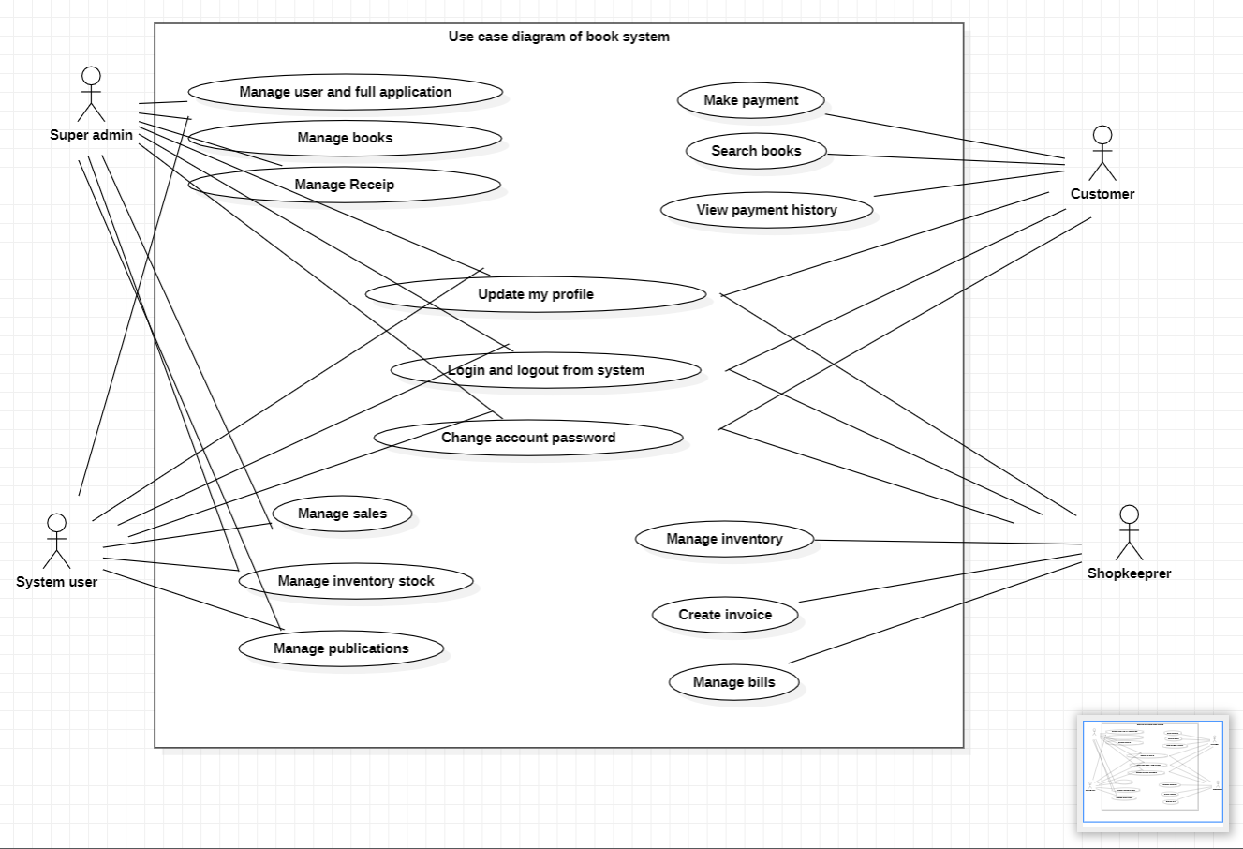

2. Data flow diagrams

1. 0 Level

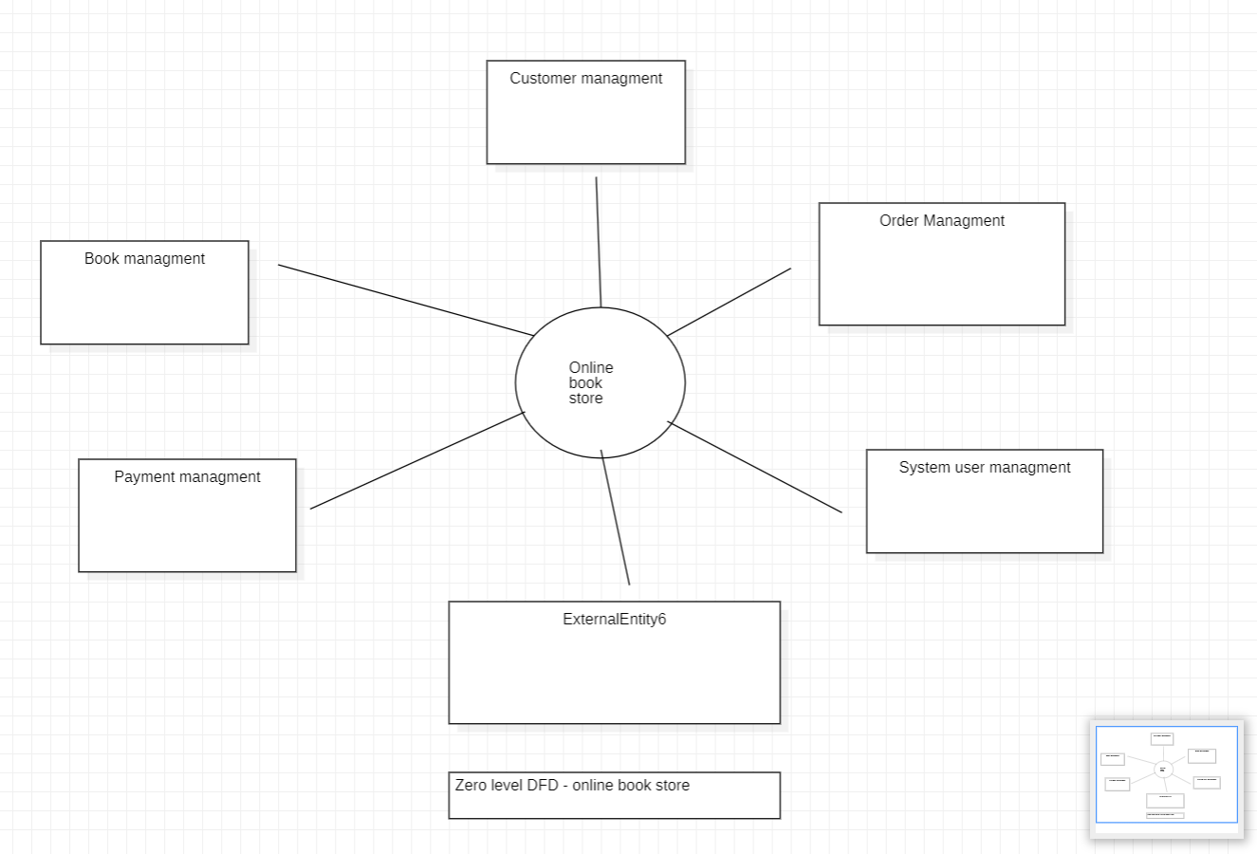

2. 1 Level

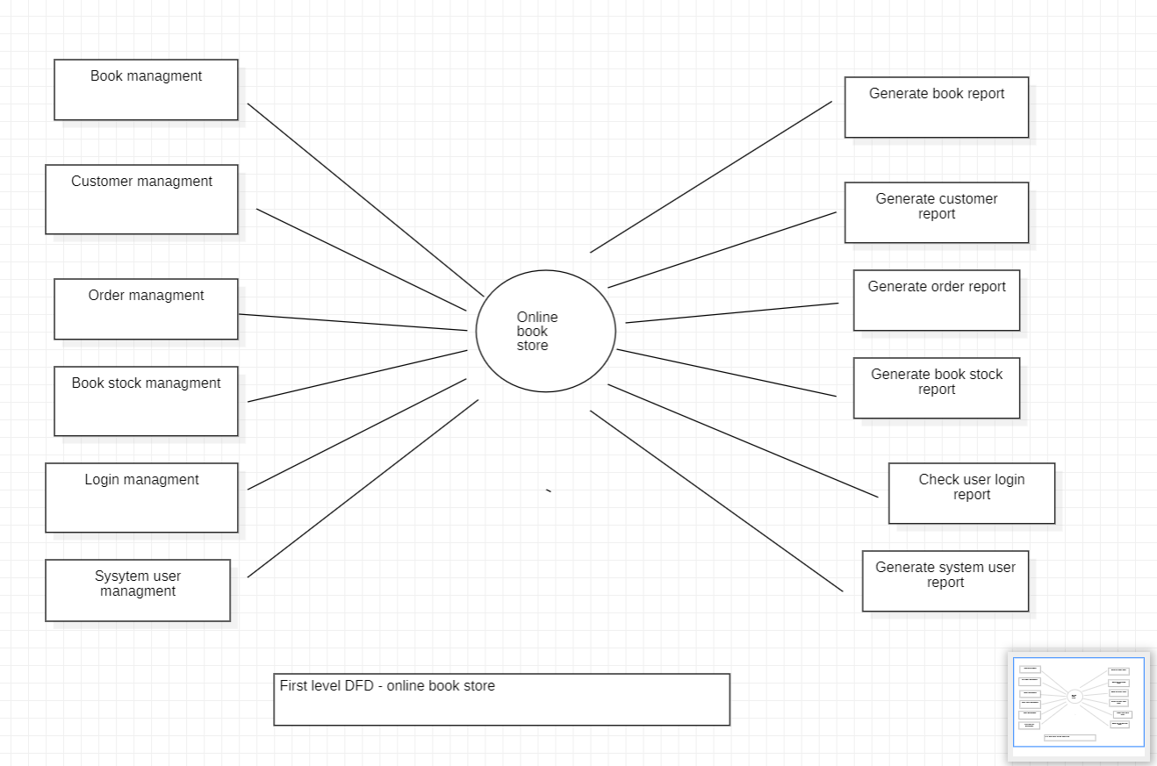

3. 2 Level

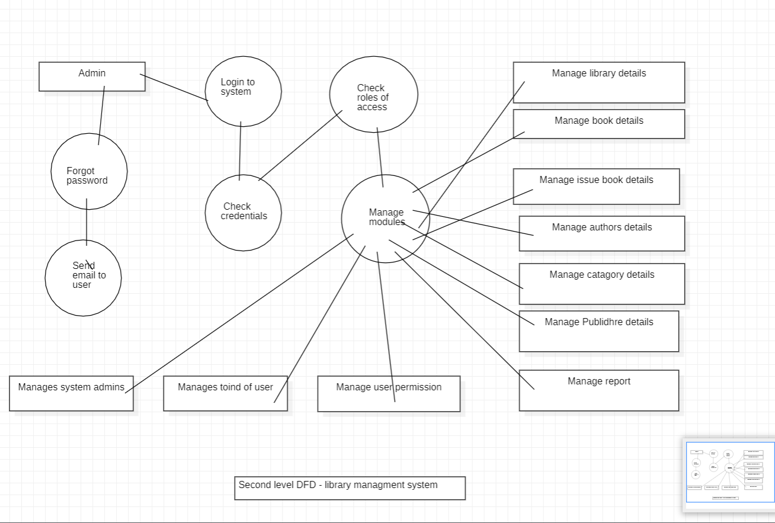

3. Class diagram

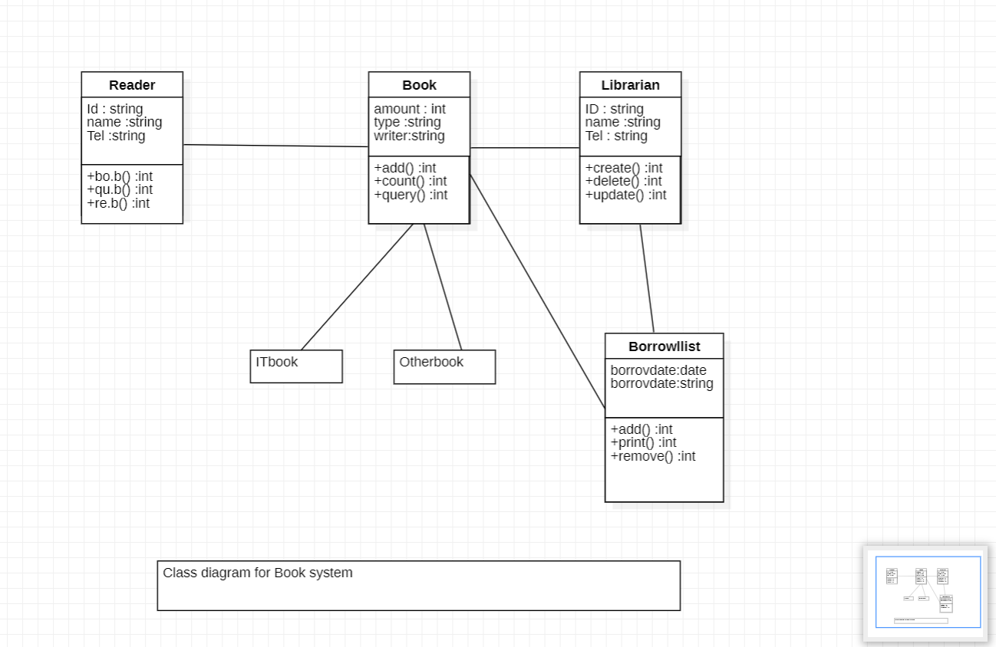

Appendix C: Issues List

This is a dynamic list of the open requirements issues that remain to be resolved, including TBDs, pending decisions, information that is needed, conflicts awaiting resolution, and the like.